The PADS | HackerRank

Question:
Generate the following two result sets:
- Query an alphabetically ordered list of all names in OCCUPATIONS, immediately followed by the first letter of each profession as a parenthetical (i.e.: enclosed in parentheses). For example: AnActorName(A), ADoctorName(D), AProfessorName(P), and ASingerName(S).
- Query the number of ocurrences of each occupation in OCCUPATIONS. Sort the occurrences in ascending order, and output them in the following format:
There are a total of [occupation_count] [occupation]s.
where [occupation_count] is the number of occurrences of an occupation in OCCUPATIONS and [occupation] is the lowercase occupation name. If more than one Occupation has the same [occupation_count], they should be ordered alphabetically.
Note: There will be at least two entries in the table for each type of occupation.
Input Format
The OCCUPATIONS table is described as follows:
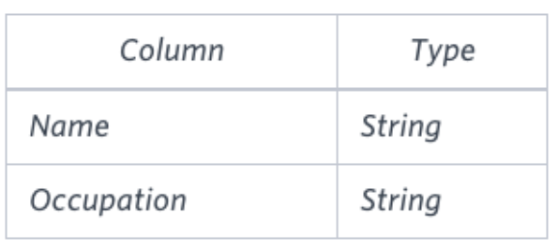
Occupation will only contain one of the following values: Doctor, Professor, Singer or Actor.
Sample Input
An OCCUPATIONS table that contains the following records:
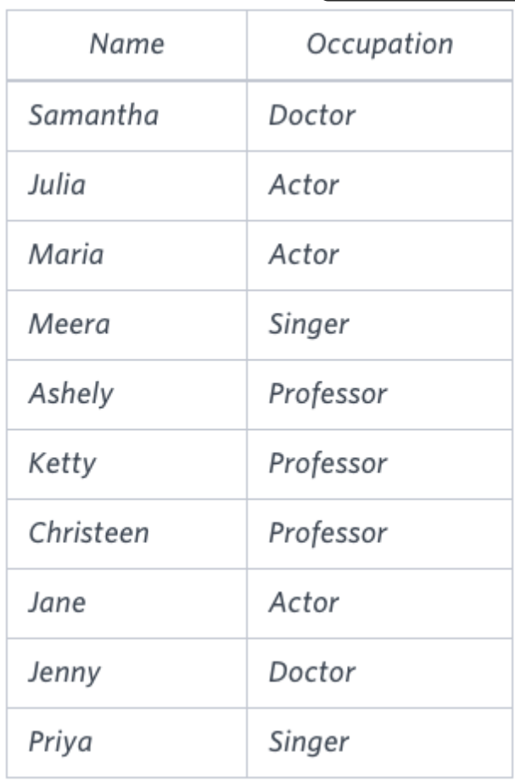
Sample Output
Ashely(P)
Christeen(P)
Jane(A)
Jenny(D)
Julia(A)
Ketty(P)
Maria(A)
Meera(S)
Priya(S)
Samantha(D)
There are a total of 2 doctors.
There are a total of 2 singers.
There are a total of 3 actors.
There are a total of 3 professors.

Explanation
The results of the first query are formatted to the problem description's specifications.
The results of the second query are ascendingly ordered first by number of names corresponding to each profession (2<=2<=3<=3), and then alphabetically by profession (doctor<=singer, and actor<=professor).

Answer:
select name||
case
when occupation = 'Doctor' then '(D)'
when occupation = 'Actor' then '(A)'
when occupation = 'Singer' then '(S)'
when occupation = 'Professor' then '(P)'
end as occupation_name,
'' as dummy_column
FROM occupations
UNION
select 'There are a total of ' as content,
count(*) ||
case
when occupation = 'Doctor' then ' doctors.'
when occupation = 'Actor' then ' actors.'
when occupation = 'Singer' then ' singers.'
when occupation = 'Professor' then ' professors.'
end as occupation_count
from occupations
group by occupation
ORDER BY 1;

Order By:
One query cannot contain two order by So, below order by are replaced by order by 1.
ORDER BY name asc  ORDER BY count(*) asc | ORDER BY 1

Casting:
Number to String: cast(count(*) as varchar(10)),

